Vitiligo Progress Report

Name: Test Patient

Age: 28

Gender: Female

Weeks Between Photos: 5

Change in Affected Area: -1.72%

Before Image:

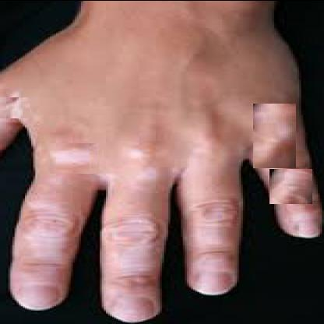

After Image:

